[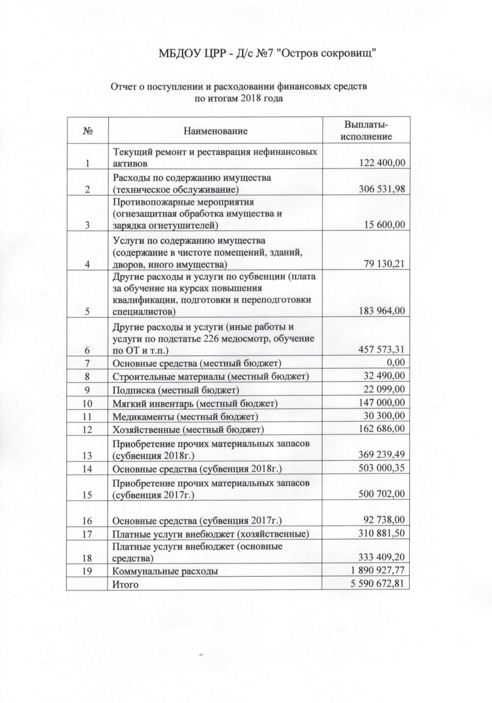](http://detsad7.yaguo.ru/%d0%bf%d0%bb%d0%b0%d0%bd-%d1%84%d1%85%d0%b4/%d0%be%d1%82%d1%87%d0%b5%d1%82-%d0%be-%d0%bf%d0%be%d1%81%d1%82%d1%83%d0%bf%d0%bb%d0%b5%d0%bd%d0%b8%d0%b8-%d0%b8-%d1%80%d0%b0%d1%81%d1%85%d0%be%d0%b4%d0%be%d0%b2%d0%b0%d0%bd%d0%b8%d0%b8-%d1%84%d0%b8-3/)